A Video Store System: design and implementation
Description: The purpose of this project is to design and implement, using proper software engineering methodology, a complete system for a Video Store. The system will be used to perform a number of functionalities such as: adding/removing/updating the list of videos that can be rented; adding/removing/updating information on customers; renting a video; returning a video; buying a video; maintenance of the system.
System Description
The Video Store system herein called VS was is to be designed to be used in a video store that rents and sells video copies and games. Both games and videos have a title and may have many copies of a given game or video.
The VS only allows members to rent copies of videos and games, however any customer may purchase a copy of a game or video. VS members have a membership card which has a barcodes and is used when trying to rent a video or game.
Video store employees may create new membership listings. Employees may utilize the VS to help customers search for a copy of a video or game. The VS is also used to add and remove copies of videos or games, reserve copies and to sell copies of videos or games. When a customer rents a item their membership card and the item are scanned using the barcode scanner, this allows the employee to retrieve customer account information and information on the item such as if it is a game or video, how much it rents for, return date, the selling price and if it was reserved.
In addition to employees, there are administrators who are able to renew or suspend privileges, add or remove titles from the database, and update account information.
When members return items, an employee scans the items to clear it from the member’s account. At the same time, the item is checked to see if it is overdue.
Items returned late will incur a late fee for every additional day past the scheduled return date. The VS checks daily for overdue items and update the corresponding members account to ban them from renting additional items. The VS system also automatically emails an overdue notice to the overdue customers reminding them that the item they rented is overdue and requesting them to return it.
Members can reserve an item that currently has no copies in stock. The reservation can be held for a week after the item copy becomes available. When the item becomes available, if the member’s account information contains an email, the email system would automatically notify the member of the availability of the item. After a week of being on hold, the item is available for rent or purchase.

Actors
Customer: any person who is a non-member

Member: any person who has paid membership fees and has a valid membership card

Employee: an employee of the store who can sell or rent copies of videos or games , collects returned items , searches for items and makes reservations

Administrator: an employee of the store who can update membership information, modify video and game titles, bar/reinstate member privileges

Bar Code Scanner: used to scan the barcode on membership cards, video and game copies.

Email System: sends emails to members notifiying them of the status of their rentals and reservations

Database: a management system that stores all video and game information such as titles, price and number of copies along with the member’s information.

Calendar and Clock System: provides system information such as time and date and is used to trigger the automatic email notification of overdue rentals.

Printer: prints receipts and membership cards

Use Case Diagrams
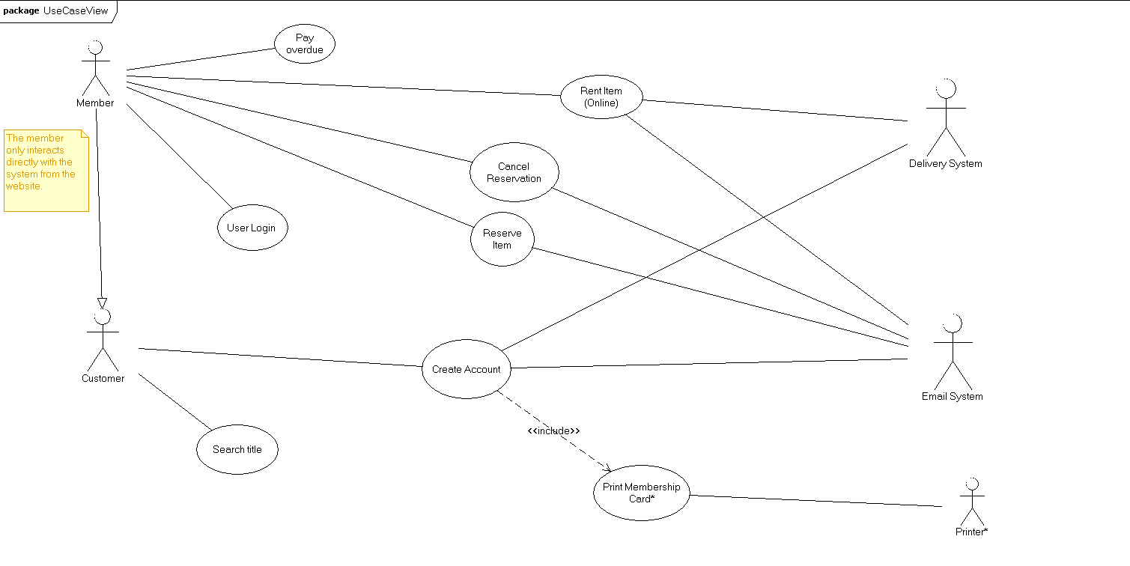
Figure : Customer's View Use Case Diagram

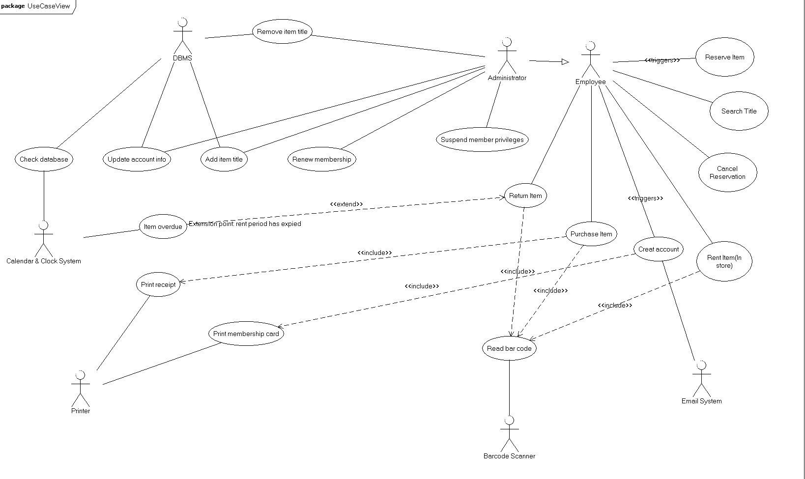
Figure : Employee's View Use Case Diagram

Use Case Descriptions

Use case name: Rent Item(Online)
Primary actor: Member
Secondary Actors(s): Delivery system, Email system
Precondition: Member has logged into his/her account on the Video Store website
Basic flow
1.Member selects item(s) to rent.
2.The system queues items until Member clicks “DONE” button.
3.The system checks the status of all selected items.
4.If all items are in-stock, the system displays the pricing for renting each item and also the total.
5.Member accepts fees.
6.The system credits fees to the Member's account.
7. The system sends list of items to be delivered to Member's address.
8. Delivery system queues the order.
9. Email system sends the Member the details of his/her order, including date for when delivery would be made, pricing details, members account details as well.

Postcondition: Delivery system has confirmed receipt of list of items to be rented by Member, and prepares for delivery.

Specific Alternative flow
BFS #4
If one of the items selected is unavailable i.e. all copies are off the shelf,
- The system displays price to rent in-stock items and prompts Member of the option to reserve the unavailable item.
- If Member selects option to reserve item, the system INCLUDES USE CASE Reserve Item.
- Return to BFS #5

BFS #4 (SAF #2)
If Member doesn't wish to reserve item,
- The system dequeues unavailable item.
- Calculates new balance without unavailable item.
- Returns to BFS #5

Global Alternative flow

Use case name: Search Title
Primary actor: Customer
Secondary Actor(s): None
Precondition: Customer clicks on 'search' option on website
Basic flow
- Customer types in title of item.
- Customer selects whether video or videogame.
- Customer presses 'enter' key

Postcondition: The system displays all search results and gives options on what actions can be taken on each item.

Specific Alternative flow

Global Alternative flow

Use case name: Create account
Primary actor: Customer
Secondary Actor(s): Email system
Precondition: Customer does not have an account.
Basic flow
- The system asks for customer's information.
- Customer enters all requested information.
- The system VALIDATES all entered information.
- IF customer's information is valid, the system stores customer's information
- The system via Email System, sends an email to the email entered by Customer, gvin the details the account and a temporary card for the Customer to print out.

Postcondition: Customer is a Member.

Specific Alternative flow
BFS #4
If customer's information is invalid,
- The system displays error message “Invalid <entry section>”
- Return to BFS #1

Global Alternative flow

Use case name: Cancel reservation
Primary actor: Member
Secondary Actors(s): Email system
Precondition: Member has an item reserved for him/her.
Basic flow
- Member clicks on item that has been reserved.
- The system displays items status and reservation details.
- Member clicks cancel reservation button.
- The system removes the reservation on the item.
- The system via the Email system, sends an email to Member, confirming the cancellation of the reservation.

Postcondition: The item is no more on reserve for Member

Specific Alternative flow

Global Alternative flow

Employee side Use Case Diagram

Use case name: Rent Item(In-store)
Primary actor: Employee
Secondary Actors(s): Member, Bar code Scanner
Dependency: INCLUDES USE CASE Read Barcode
Precondition: Member has presented the Employee with an item(s) to rent.
Basic flow
- Employee requests Membership card.
- Employee scans membership card, INCLUDES USE CASE Read Barcode
- The system VALIDATES the Membership card
- If card is valid, the system returns the member's account information.
- Employee scans the item(s), INCLUDE USE CASE Read Barcode.
- The system returns the price(s) to rent video.
- The system adds item(s) to members account.
- The system returns a return date for rented item.

Postcondition: Item is ready for member to take home, after payment.

Specific Alternative flow
BFS #4
If the membership card is not valid,
- Then Employee does not allow Customer to rent the item(s).
- Employee gives Customer option of purchasing item(s).

Global Alternative flow

Use case name: Renew Membership
Primary actor: Employee
Secondary Actors(s): None
Precondition: Membership has reached expiry date
Basic flow
- The system prompts for membership card to be scanned.
- Employee scans membership card.
- The system displays account details and amount for renewal
- The system INCLUDES USE CASE Pay Dues

Postcondition: Membership card is made valid and expiry date is returned

Specific Alternative flow
Global Alternative flow

Use case name: Return Item
Primary actor: Employee
Secondary Actors(s): Barcode Scanner
Precondition: Employee obtains item(s) from Member

Basic flow

- Employee scans membership card.
- The system displays list of items the Member is yet to return.
- The system prompts the Employee to scan item(s)
- Employee scans item, and the system INCLUDES USE CASE Read Barcode
- The system matches the scanned item(s) with item(s) on the list of items that have not been returned.
- IF the scanned item matches with any of the items on the displayed list, the item is removed from the list of items not returned.

Postcondition: The system status the status of all returned items to “in-stock”

Specific Alternative flow
BFS #6
IF the scanned item does not match any item on the displayed list,
- The system displays message “ Item has already been returned ”
- Return to BFS #3

Global Alternative flow

